TUTORIAL 9

Module name:Black Box, White Box, Integration & System Testing
Website:https://opensource-demo.orangehrmlive.com/web/index.php/auth/login

A. Black Box Testing

TC01 – Valid Login
Module Name: Login Module
Steps:
- Open the OrangeHRM Demo website.
- Enter username .
- Enter password .
- Click on the Login button.
- Check whether the Dashboard opens.
Screenshot: 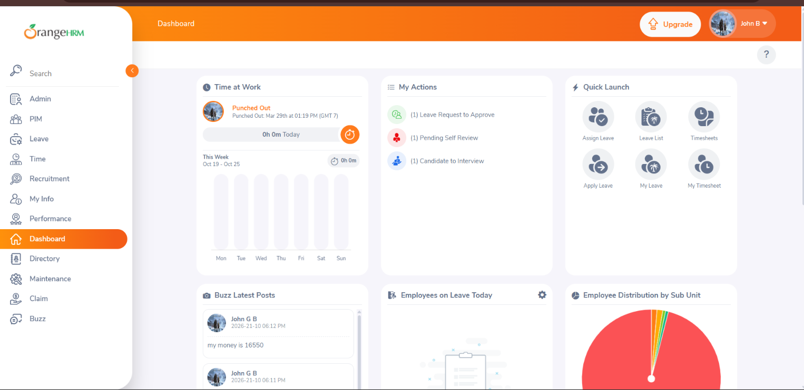
Actual result:log in successfully and the Dashboard should appear.
Status:pass

TC02 – Invalid Login
Module Name: Login Module
Steps:
- Open the OrangeHRM Demo website.
- Enter an incorrect username or password.
- Click on Login.
- Check the displayed message.
Screenshot: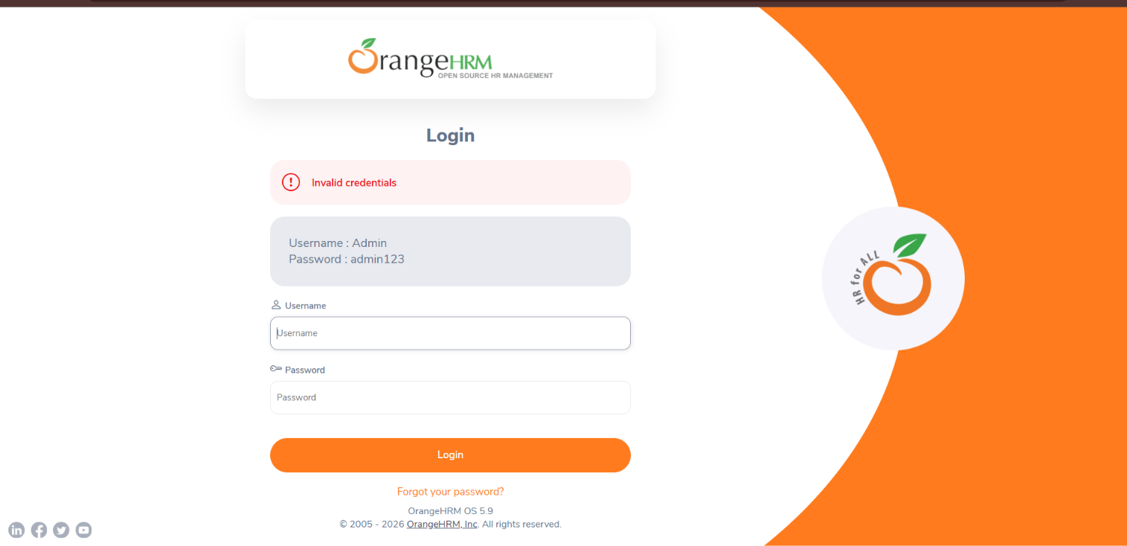
Actual Result: Invalid credentials message displayed.
Status: PASS

TC03 – Blank Login
Module Name: Login Module
Steps:
- Open the OrangeHRM Demo website.
- Keep the username and password fields empty.
- Click on Login.
- Check the validation messages.
Screenshot: 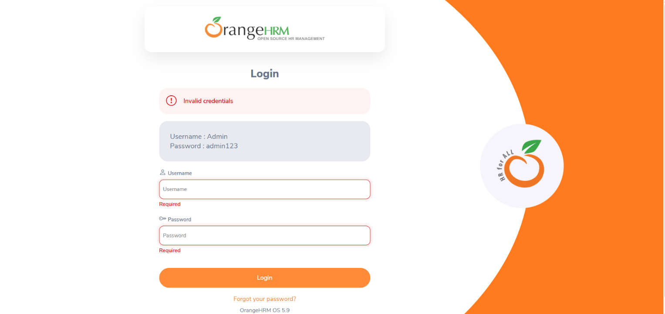
Actual Result: Required messages are displayed for both username and password fields.
Status: PASS

B. White Box Testing

TC04 – Login Condition Checking
Module Name: Login Logic
Steps:
- Check the login validation logic in the source code, if available.
- Verify the username condition.
- Verify the password condition.
- Check the successful and unsuccessful login paths.
Screenshot: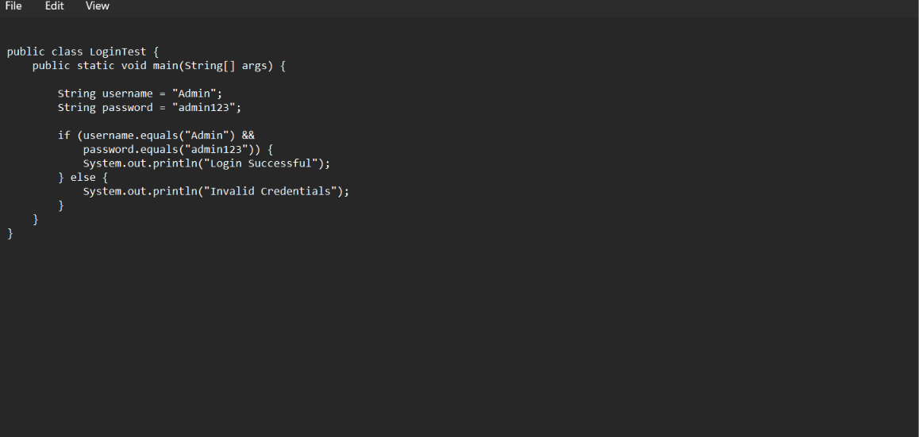
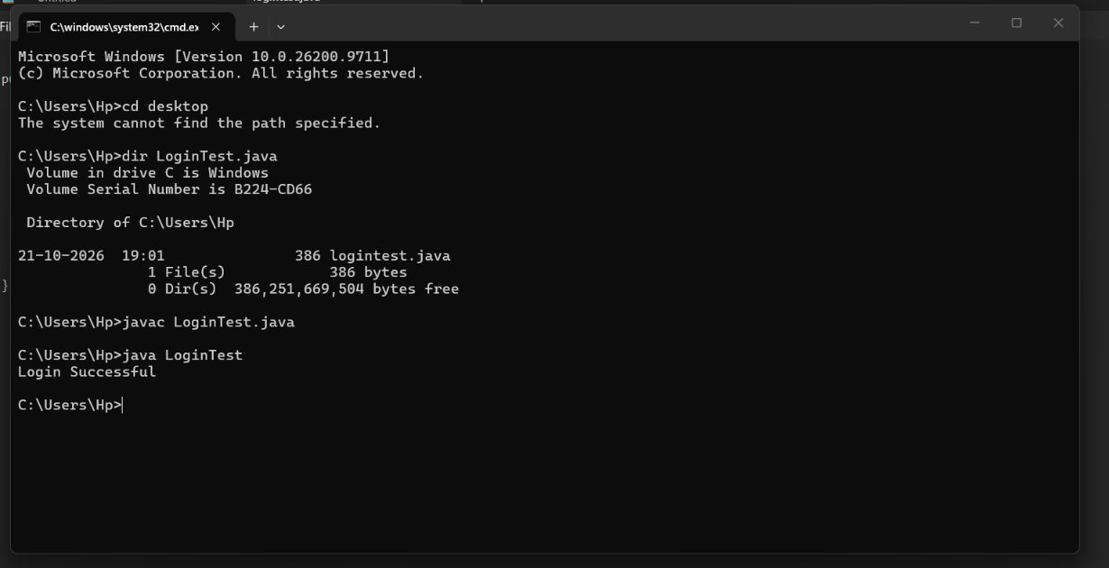

Actual Result: Login Successful.
Status: PASS

TC05 – Required Field Validation Logic
Module Name: Form Validation
Steps:
- Review the form validation logic in the source code, if available.
- Check the condition for empty fields.
- Check the condition for valid input.
- Verify the validation output.
Screenshot: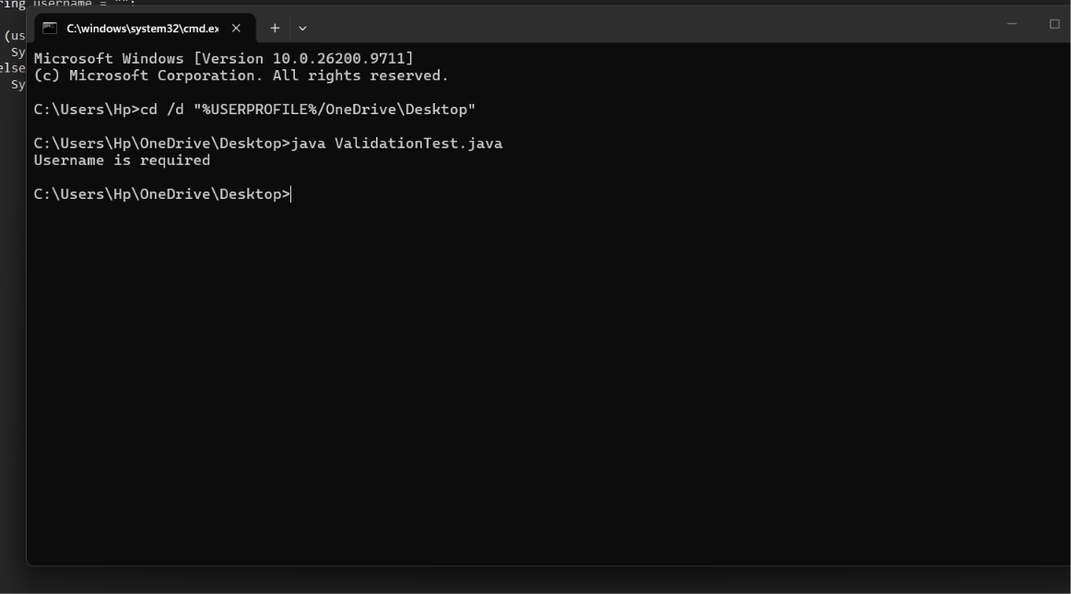
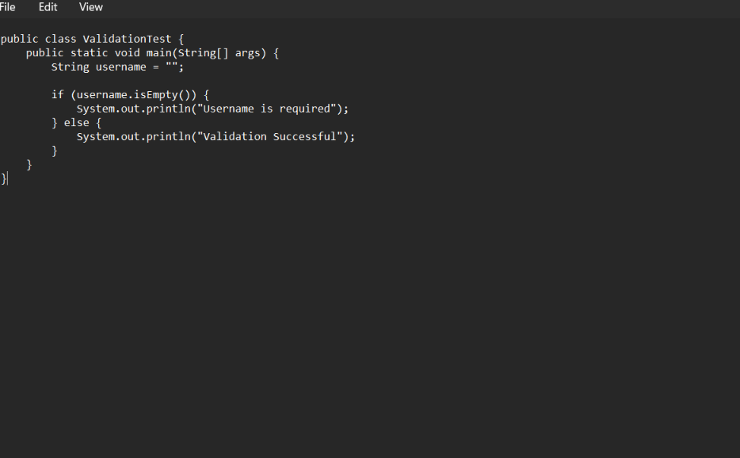
Actual Result: Username is required message displayed when the username is empty.
Status: Pass

C. Integration Testing

TC06 – Login to Dashboard
Module Name: Login and Dashboard
Steps:
- Open the OrangeHRM Demo website.
- Enter valid login details.
- Click on Login.
- Verify that the Dashboard opens.
Screenshot: 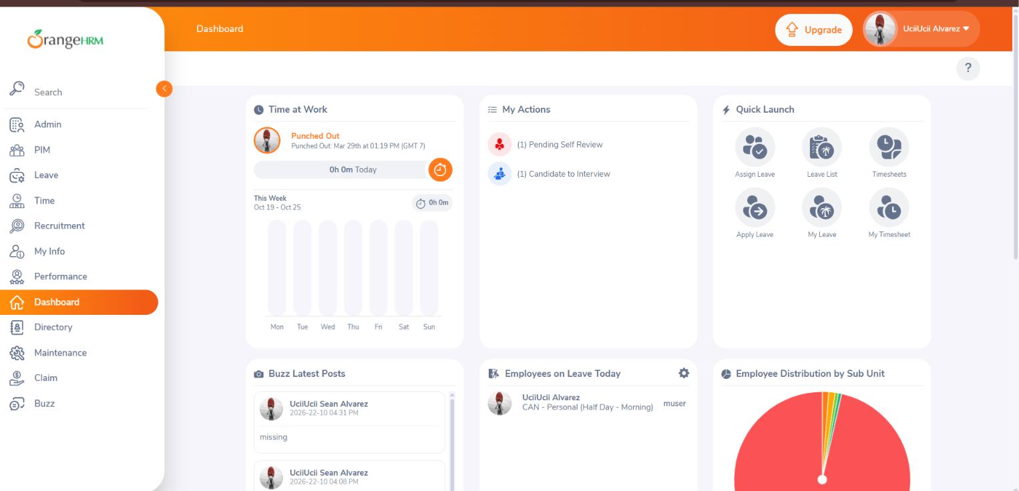

Actual Result: Dashboard page opened successfully after entering valid login credentials.
Status: PASS

TC07 – Dashboard to Employee Management
Module Name: Dashboard and Employee Management
Steps:
- Log in to the website.
- Open the PIM (Employee Management) module.
- Check whether the employee list page opens.
- Verify the available employee management options.
Screenshot: 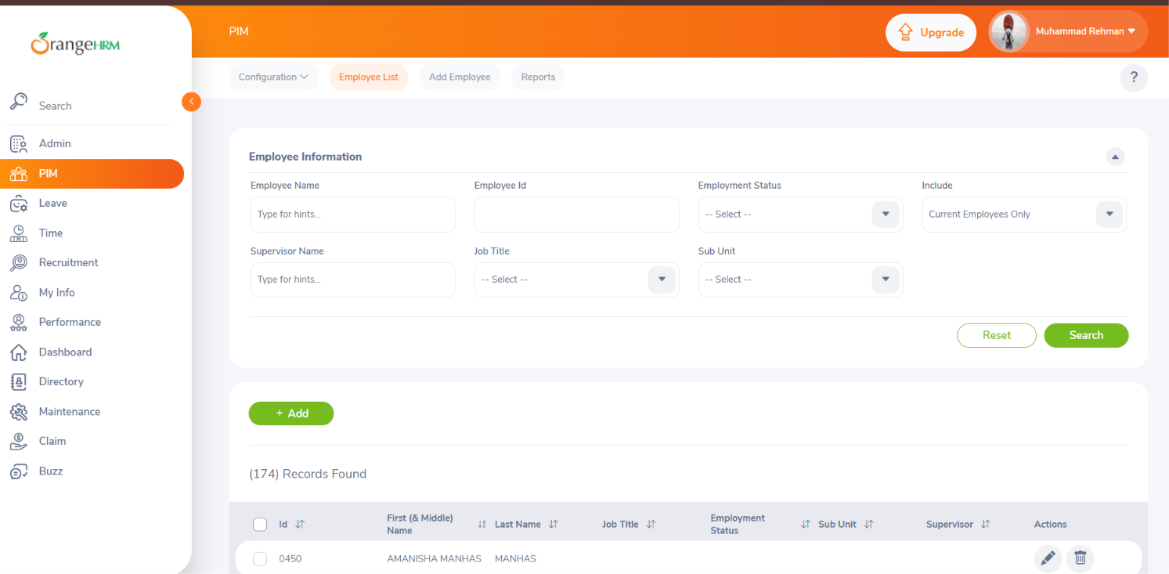

Actual Result: Employee list page opened successfully and management options were displayed.
Status: PASS

D. System Testing

TC08 – Complete Workflow
Module Name: Complete Application Workflow
Steps:
- Open the OrangeHRM Demo website.
- Log in with valid credentials.
- Verify the Dashboard.
- Open the PIM module.
- Check the employee management page.
- Navigate back to the Dashboard.
- Log out of the application.
Screenshots: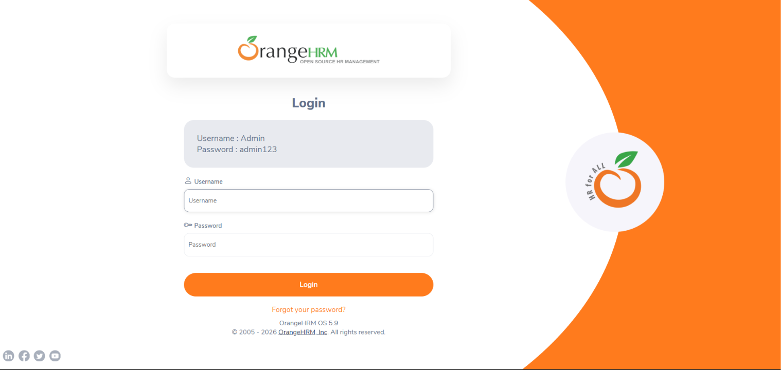
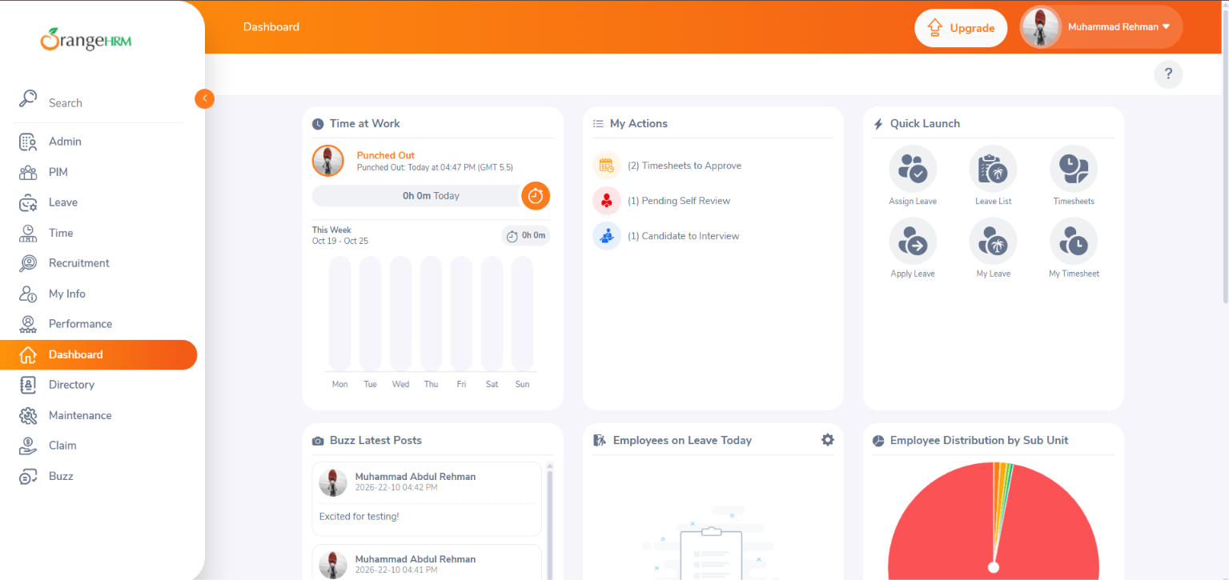

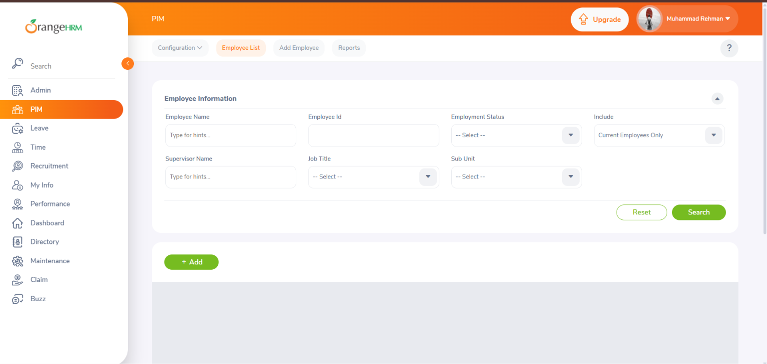
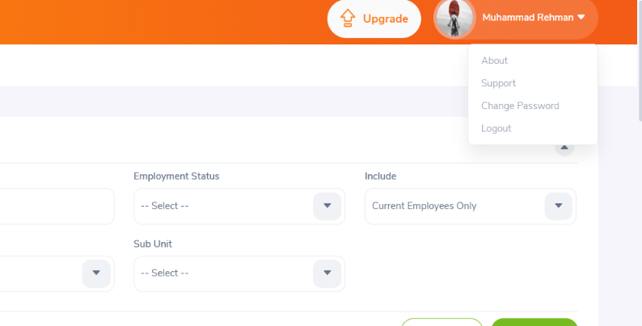

Actual Result: Complete workflow was performed successfully. Login, Dashboard, PIM module, and Logout worked as expected.
Status: PASS

Conclusion
In this project, the OrangeHRM Demo Website is tested using Black Box, White Box, Integration and System Testing concepts. The test cases cover login validation, application logic, navigation between modules and the complete workflow. The final result will be determined after executing the test cases and recording the actual results.

